# Tabletop MRI Lab – BMP 211 – Fall 2022

# Introduction

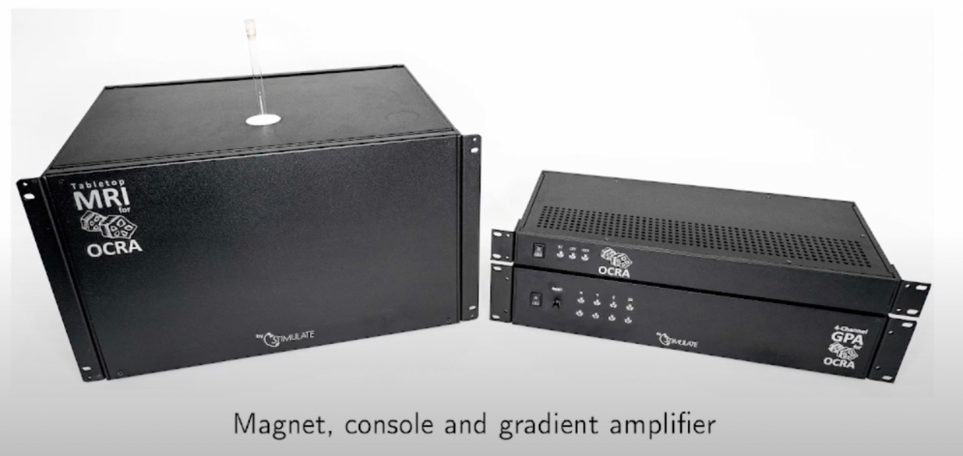The purpose of this lab is to familiarize you with the MRI Physics concepts we talked about in class and to help you understand how an MRI scanner works! The system you will use is called OCRA: Open-source Console for Real-time Acquisition. The design came together from people all over the world. The MR Physics group at Harvard University/ Massachusetts Institute of Technology created an open-source tabletop scanner. Several students from Germsoany visited MGH and worked with the system to return to Germany to build a commercial product for a tabletop system at the Research Campus STIMULATE of the Otto-von-Guericke University Magdeburg (Germany). At Stanford University, we have acquired three OCRA tabletop systems and have worked on setting up these scanners for use to review the MRI concepts we have learned in our class.

**Figure 1:** Image of Tabletop system which includes the magnet (Left)

# Tabletop MRI Scanners Components

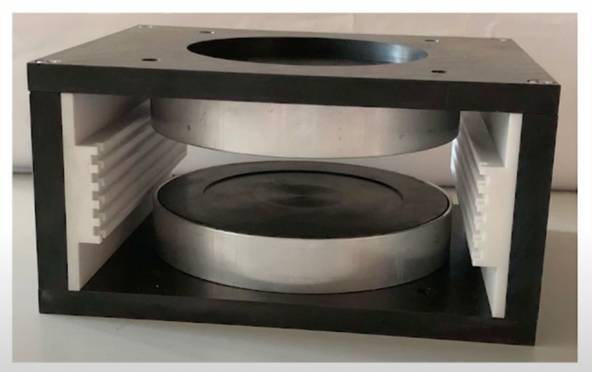There are several components associated with the MRI Scanners you will be working with. The primary components are described as follows:

**Magnet:** The B0 field is created by small 0.26T permanent magnetic. The two rare-earth magnetic disks are held apart with an iron yoke which also provides a flux-return path for the magnetic field, containing the magnetic field to the gap between the pole pieces (and inside the iron).

**Figure 2:** Inside of magnet box

**Phantoms:** Phantoms are artificial imaging samples with known dimensions and features. For this MRI system, the imaging phantoms are contained in 1 cm diameter glass tubes.

**RF coil:** The RF coil for this system is used for transmitting the excitation pulse to get the magnetization precessing and to detect the MRI signal through the Faraday detection principle. The coil is a simple solenoid design. In order for the RF coil to be sensitive to the measured Larmour frequency, it is built as an electrical resonator with parallel capacitance. The coil is enclosed by an RF shield consisting of 4 printed circuit boards soldered edge to edge. This shield acts as faraday cage to protect surrounding electronics from the RF radiation.

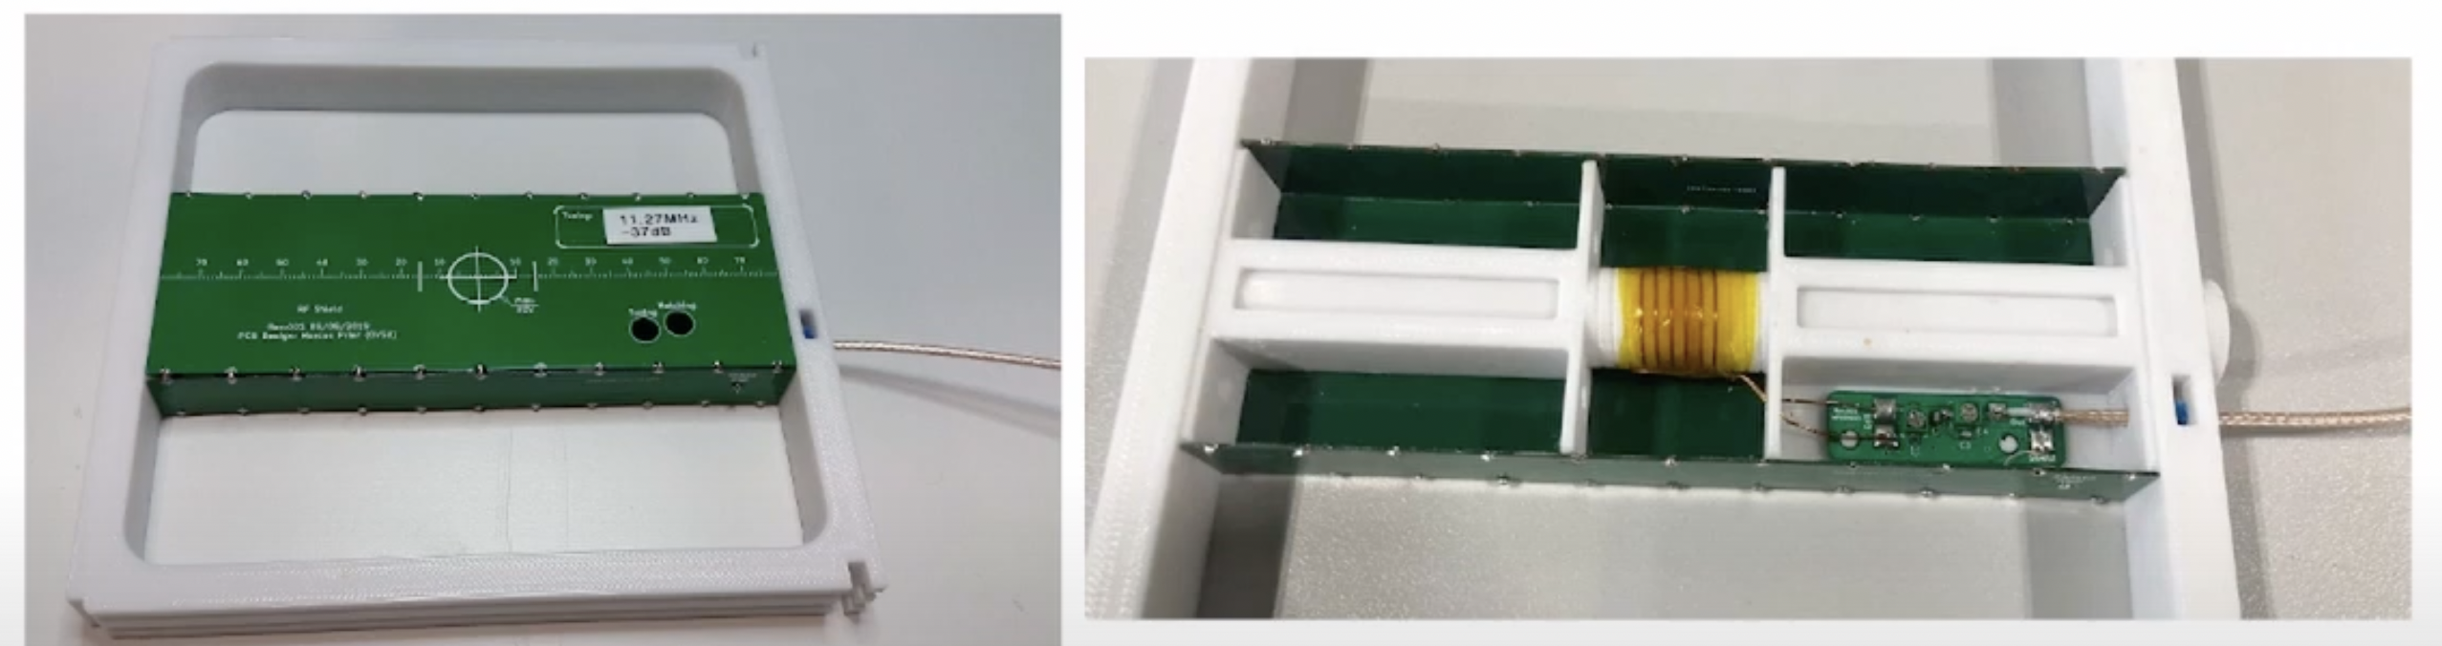

**Figure 3:** (Left) RF box shielding made of 4 printed circuit boards. (Right) solenoid inside the 4 circuit boards.

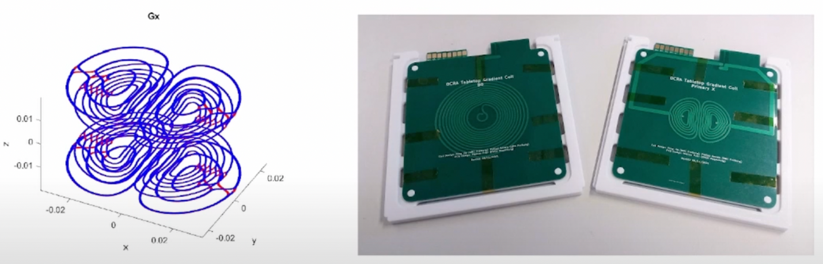**Gradient Coils:** The gradient amplifier is used to supply the current to the gradient coils. Since it's the fields we care about, and the fields are proportional to current, this amplifier can be viewed as a voltage to current transducer; it takes a voltage waveform from the console and creates a current proportional to that voltage in the gradient coil. It is like a common audio power amplifier except that it must also be able to output DC currents. It uses a power op-amp followed by a current sensor. The output of the current sensor is compared to the input voltage to ensure that the current itself is proportional to the input voltage. A current sensor is created by measuring the voltage across a small resistor in series with the output.

**Figure 4:** Example of gradients which are PCB printed.

**RF Box and Gradient Filter:** The RF box contains several RF related components including an RF amplifier, transmit and receive switches, and first and second stage preamplifiers for received spin signal.  The TR-switch is used to connect the RF-coil (antenna) to the RF Power-Amplifier in transmit mode or the antenna to the low noise pre-amplifier in receive mode. The Gradient Filter Box contains connections to the gradient channels and feedthrough capacitators to shield noise from the gradient amplifier.

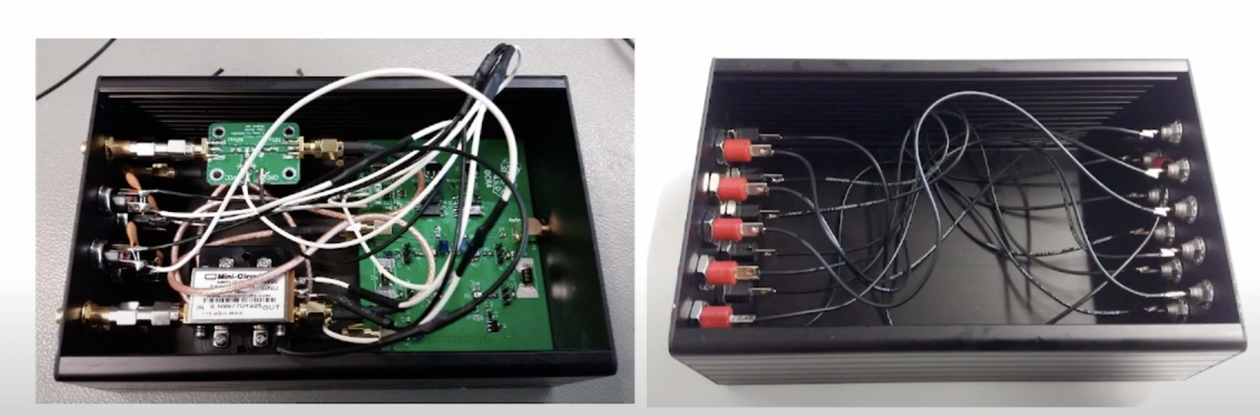

**Figure 5:** (Left) RF Box and (Right) Gradient Filter which are located in the magnet box.

**Console:** The console is in one box and contains two primary components which are the red pitaya and the Ocra1. The red pitaya is a commercially available microcontroller interfaces with a basic MRI console and coordinates the image acquisition by generated RF pulses and control signals for the transmit-receive switch. The received magnetic resonance signal, generated at the RF coil in the system, is sampled at an RF input channel through the integrated ADC (RX). The Red Pitaya is connected to the Ocra1 board which has 4 18-bit digital to analog converters for the gradient waveform generation and an RF attenuator to scale the Red Pitaya output to the RF amplifier input. The console also contains the power supply and a power circuit to distribute the power to different parts.

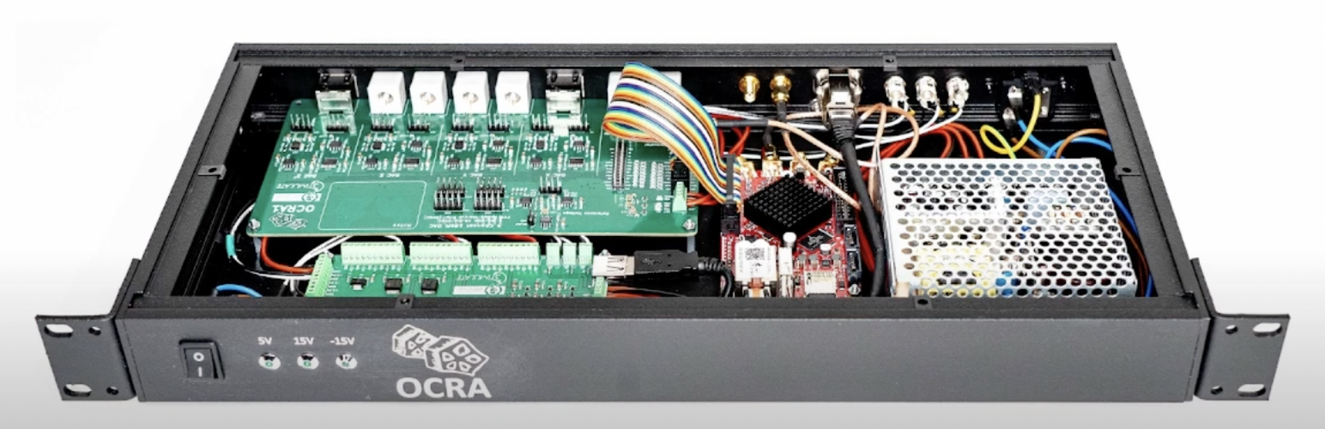

**Figure 6:** Inside of the console box where there is the Red Pitaya and the Ocra1.

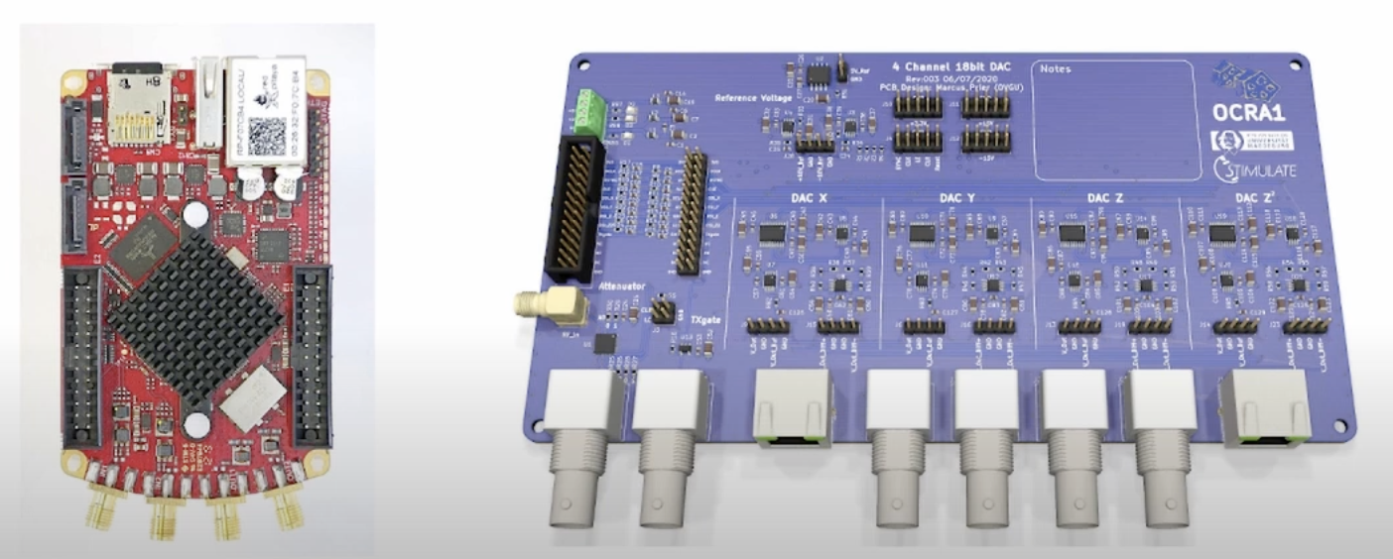

**Figure 7:** (Left) Red Pitaya and (Right) Ocra 1 individually not in the RF box.

**Gradient Amplifier:** The four-channel gradient amplifier (X, Y, Z, Z2) contains current protection to protect coils and temperature protection to protect the end stage of each channel. Inside there is also a large power supply and printed circuit boards for the amplifiers. 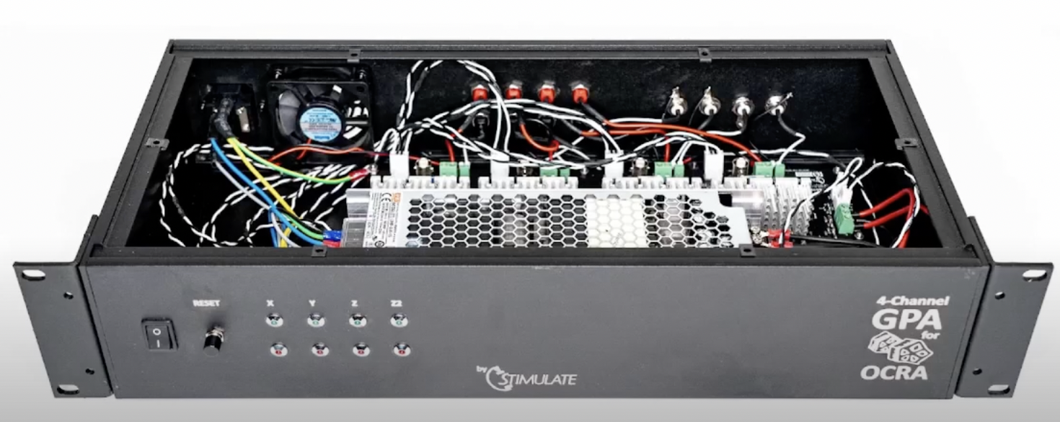

**Figure 8:** Gradient amplifier with X, Y, Z and Z2 channels. The additional channel Z2 is used not for imaging but rather for maintaining homogeneity of the magnetic field.

**Graphical User Interface**: The Raspberry Pi is the graphical user interface that interfaces with the Red Pitaya and the user via Python. It translates Python sequence into RF transmit pulses and gradient waveforms and allows the user to interface with the tabletop scanner.

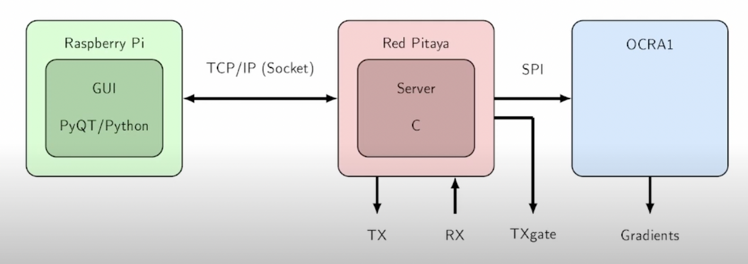

**Figure 9:** Overview of the connections between the graphical user interface (Raspberry Pi) to the Red Pitaya which communicates with the OCRA1 to do MRI image. The Rapsberry Pi provides the interface for the user to change sequence parameters and interact with the system. The Raspberry Pi communicates to the Red Pitaya via an TCP/IP Socket. The OCRA1 extends the Red Pitaya to a basic MRI console via serial peripheral interface (SPI) bus given by the RP GPIO pins. The Red Pitaya coordinates the image acquisition by generating RF pulses (TX) and control signals for the transmit-receive switch (TXgate).

# Lab Instructions

## Turning on Your Machine

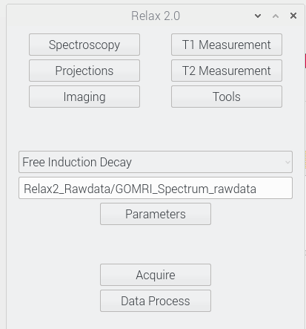Ensure that all connections are set up properly. Switch the small Control Box on followed by the gradient box. Click and hold the reset button to reset the gradients, which should have indicators light up as green. Then, plug in your raspberry pi and login. The password will be *raspberry*, all lowercase. Click on the Folder icon in the bottom left-hand corner of the screen. Click into the folder Relax2 (/home/pi/Relax2) then double click to open Relax2_main.py. In the python script screen, click the green arrow button. A Dialog Box will appear to select an IP address. Select the IP address shown and click connect. We are now in the main python script.

**Figure 10:** Main menu of the GUI. Top section are buttons for types of scans that can be specified in the drop-down menu where Spin Echo is. Acquire Runs the sequences and Data Process displays results.

## Saving and Screenshotting

For this lab, you will be using raw data as well as screenshotting several results. Raw data for sequences are stored in /home/pi/Relax2/Relax2_Rawdata. Image data if saved is in /home/pi/Relax2/Relax2_Imagedata. Both formats are text files. To screenshot, open a terminal and use *scrot filename.png* which will screenshot the screen and save to the current directory. You can utilize a flash drive to transfer the file offline to your own computer.

## System Parameters

For the labs, we will generally provide a recommended echo time (TE) and repetition time (TR). The TE

## Calibrate Your Machine

In a magnetic field the protons in water protons are processing at a particular resonant frequency. The center frequency calibration tells the scanner exactly what frequency the protons of water are resonating at in the magnet’s isocenter such that when the protons are excited, we can receive the signal. Although we know approximately what this frequency should be based on the magnetic field strength and the gyromagnetic ratio, the frequency can be sensitive to temperature shifts and environmental changes, so it is important to calibrate your machine before imaging. In the following steps we will identify the center frequency and tune the signal to have the highest quality calibration for our next experiments.

### FINDING THE CENTER FREQUENCY

Before imaging, we need to calibrate our machine by identifying the center frequency.

Use a water-only filled test-tube phantom for this configuration. The phantom will be placed in the appropriate space.

**Figure 11:** Model of the experiment used to find the center frequency. We are interested in localizing the scanner such that we can sample right at the center of the echo. A basic spin echo sequence is used. Some values are shown that we program for the scanner including the RF pulselength, TE, TR, and the sampling time.

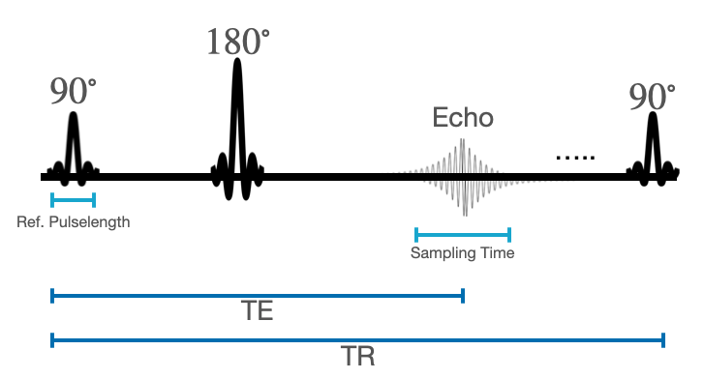

To configure the protocol, we will do the following:

1. In the main menu, select Spectroscopy then in the Sequences selection dropdown select Spin Echo. Then click on the Parameters screen which opens several customizations of the sequence.
2. Set the 90-degree Ref. RF Pulse length
3. to 100 µs and RF Attenuation to -15 dB. Set the TE to 15 ms and the TR to at least 1000 ms. The sampling time should be set to 8 ms. The parameters are automatically updated.
4. To acquire data, click Acquire. Then data process. There should be a pop-up showing the signal and the real and imaginary spectrums. We want this signal to be centered which will improve and allow us to do our later imaging. Along with the plot there is a statistics window that reports Center Frequency, FWHM, SNR, and B0 inhomogeneity of the signal. This is a useful display to understand how good our signal is.
5. To then adjust the center frequency, go to Parameters and click the “Recenter” button under the RF Frequency tool. *If your signal appears close to the center calibration, it is still good to click recenter tool! It will make your centering even more accurate.*
6. Click Acquire and Data Process again. The spectrum should be more centered.
7. If the center frequency still does not appear center, reiterate through steps 4-5.

Q1: What is the center frequency? Please include the screenshot showing your Spin-Echo Spectrum. What is your SNR and B0 inhomogeneity in the signal?

*Note: Center frequency is extremely sensitive to temperature. If you have left the system sitting awhile, it is good practice to quickly run the spin-echo sequence and use the recenter button to set the center spectrum.*

If a distinguishable peak does not appear in the plots, you may need to do a more sensitive recalibration. Follow the steps below to do a more extensive search for the center frequency:

1. In the main window click Tools and go to the AutoCenter Tool
2. There is a note on the magnet box with the center frequency that is approximately for the magnetic (i.e., 11.25 MHz).
3. The tool will go through different center frequencies and record the peak signal, which should be highest at our tuned center frequency. Set the start and end frequencies as +/- 5 from the recorded center frequency on the box (i.e. [11.2 MHz, 11.3 MHz] for 11.25MHz). Change the step size for iterating to be 1000 Hz.
4. Click Go. This program will take some time to do.
5. When it has completed a window will appear with a plot of signal as a function of frequency. You will see a peak signal value which is also recorded in the Tool Window.
6. Open parameters and click recenter to recenter the frequency
7. Rerun the spin-echo spectroscopy sequence again. You should see a signal now!
8. You may recenter several times to be as close to the center frequency as possible.

### RF ATTENUATION/ RF Scaling

The RF Attenuation (known also as RF Scaling) feature helps further improve our RF signal. Now that we see we can have a signal we can further tune the RF to provide the best 90-degree condition. We can set different voltage that affect the signal amplitude. We want to find the appropriate energy to use to maximize signal amplitude for the 90-degree flip angle. To identify this value, we utilize the transmit adjust tool:

1. Click into Tools. There will be a subsection titled TrAdj Tool. Set the Start Attenuation to -31 dB, Stop attenuation to -1 dB, and Steps 30.
2. Make sure your overall sequence is still Spin Echo with the appropriate settings (if you just ran the previous section, you are all set)
3. Click Go
4. After the sequences runs, you will see a plot of the Signal for various scaling factors. Our best 90-degree condition is located at the scaling the gives the peak signal. It is reported on the tool screen under Ref Attenuation.
5. Set RF attenuation to this value in the parameter menu. This can be done manually or by clicking “Set to Tool Ref” under RF attenuation.
6. Rerun the Spectroscopy🡪 Spin Echo sequence. Your signal should be improved. Hit re-center again to center your frequency as it may have shifted.

Q2: Screenshot the RF attenuation plot. Identify where the best condition is for the 90-degree pulse. What is the RF attenuation you set?

Q3: Include a screenshot of your improved spin-echo spectrum. What do you notice is different than before? You can also reference the Plot values that are reported alongside the plot for comparison.

### SHIMMING

Shimming is used to improve homogeneity of the main field. We do this by adding small, constant currents (i.e. DC) to the gradient coils which, in turn, produce a linear field variation along X,Y, Z, and Z2; this will cancel the variations in B0 that exist in the magnet. The X, Y, and Z gradients are used to assist reading out frequencies and spatial localization. The Z2 gradients helps us further homogenize our main magnetic field, B0. Our goal is thus to maximize the homogeneity of the magnetic field over the sample, which means narrowing the frequency spectrum.

The area of the frequency domain spectrum is determined by the amount of magnetization (number of protons magnetized) in the sample, which is constant over time. Thus, the area under the frequency spectrum curve is fixed. By shimming, we are limiting phase dispersion due to field inhomogeneity which in turns maximizes phase coherence (i.e. more spins will precess at the same Larmor frequency). This will result in a higher peak around the resonance frequency, which produces a narrower curve in the frequency spectrum (top plot for our spectroscopy imaging) since the area stays the same.

We have already shimmed these systems and set your shim so it is close to the appropriate shim values so your signal should be adequate. In this portion we want to show you the importance of shim and the effect on the signal.

Q4: What are the current shim settings for Shim X, Shim Y, Shim Z, and Shim Z2?

1. We will now change all the shim values to 0. *Please jot down what the shim values are before zeroing!* Run a basic spin-echo that you did to find the center frequency.
2. When the resulting spectrum appears, screenshot it.
3. Change the shims back to the original settings. We have given you a shim that is close but may not be the best shim so we will iterate through the shimming process to help you see how shimming works.
4. Click the Tools Menu and go to the Shim section. In this section you select a gradient you want to test different shim values for and how many tests you will run.
5. Click the bubble to select the X gradient. Set the range of values to the current value +/- 10. Set the number of steps to 20. For example, to test a range of shims around 30 the “Start” field would be 20, “Stop” field would be 40 and “Step” field would be 20.
6. Run the tool. This will take a few seconds to iterate through the different shim settings.
7. When the script finishes at the end a plot will pop up where there should be a peak signal at a certain shim setting and a number will be reported in the tool space. Change your shim setting for the X gradient to that number. Screenshot the plot.
8. Unselect Gradient X. Then select Gradient Y. Repeat steps 5-7.
9. Repeat Steps 5-7 for Z and Z2 gradients, updating the shim for each gradient in the parameter window after each iteration. Be sure to deselect the previous gradient before moving onto the next one.
10. After you have iterated through the spins, obtain another spin-echo signal spectrum and screenshot.

Q5: Display a screenshot of the signal spectrum with the different Shim settings (all 0 and then the original values and then your perfected shim). What do you notice are differences between the signal? Why do we need to do shimming?

At this time, please close all out of all the plots you have made so far, if you have not done so yet. Please keep up the main menu and the parameter windows, but all other plots should be closed.

## Spectroscopy Imaging

### Free Induction Decay

We can also obtain a Free Induction Decay Signal. The nuclear induction signal arises as the net magnetization vector precesses around the *z*-axis (the direction of B0). The transverse components of M generate a current in the receiver coil based on the Faraday-Lenz Law of electromagnetism. The signal is a sine wave oscillating at the Larmor frequency (ωo); however, it decays over time.

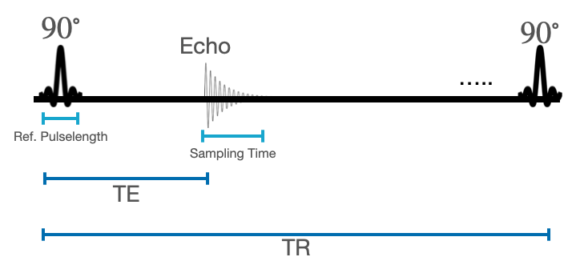

**Figure 12:** Free induction decay (FID) spectroscopy sequence. Unlike spin echo, we only play one 90 degree pulse. Parameters that we can change include the pulselength, sampling time, TE, and TR.

To obtain the spectrum we will perform the following:

1. Click Spectroscopy and then select Free Induction Decay
2. Set the 90-degree Ref. RF Pulse length to 100 µs, TE to 2 ms, and TR to at least 1000 ms
3. Click Acquire then the Data Process Button.
4. Screenshot the resultant image of the signal spectrum

Q6: In the FID spectrum, where do we see T2* Decay?

### Spin Echo

Now that you have calibrated your MRI machine, you will see what a spin echo looks like. A spin echo is made up of a series of events: 90◦ pulse - 180◦ rephasing pulse at TE/2 - signal reading at TE. Usually, this series is repeated at each TR (Repetition time) and with each repetition, a k-space line is filled, thanks to a different phase encoding. For now, we are going to focus on what happens during one TR.

1. Select Spectroscopy then Spin-echo from the dropdown menu
2. Set the 90-degree pulse length to 100 µs and TE to 15 ms.
3. Click Acquire and Data process
4. Screenshot the resultant image.

We should see the same spectrum we used during calibration. Save a screenshot of the generated image.

Q7: What are the differences between the FID and Spin Echo Spectrums in how they are generated? Include the screenshots of the two signal spectrums in your report.

### Echo Time

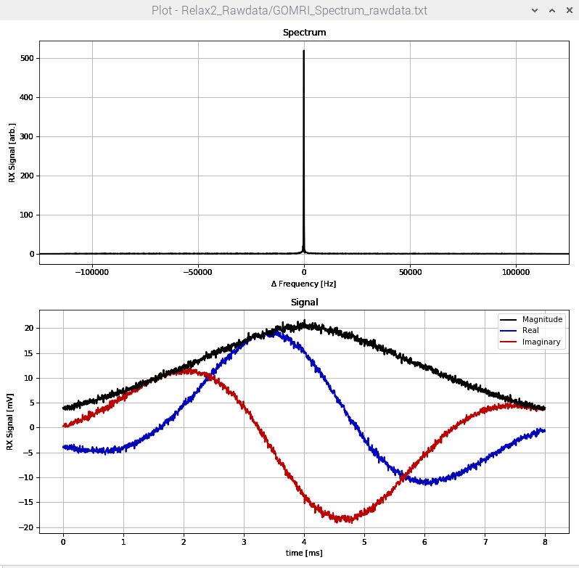Let’s also look at echo time and its effect on the Spin Echo. You will be varying the TE and reporting the max signal. When the plots appear, look at the second, bottom plot. Identify the peak magnitude signal from the graph.

**Figure 13:** Example of figure to use to identify maximum signal for the echo time experiment. This plot is the voltage which is the received voltage signal. In this example, the peak signal thus would be 20.

Using the same sequence parameters above, vary the TE by the following values:

|  |  |  |  |  |  |  |  |  |
| --- | --- | --- | --- | --- | --- | --- | --- | --- |
| TE [ms] | 5 | 50 | 100 | 200 | 300 | 400 | 500 | 600 |
| Peak Signal |  |  |  |  |  |  |  |  |
| TE [ms] | 700 | 800 | 900 | 1000 | 1100 | 1200 | 1300 | 1500 |
| Peak Signal |  |  |  |  |  |  |  |  |

Q8: How does the acquired signal change when TE is increased or decreased?

Bonus! Plot the signal as a function of TE in your favorite programming language. What is the estimated T2?

## Projection Imaging

The goal of this part of the lab is to learn about 1D projection imaging. We will do so by applying some gradients in the direction of the desired projection. The y axis points along the magnet vertically, x points to the right facing the scanner and the z direction points forward.

For projection imaging, a readout gradient is applied for one spatial direction (x, y, or z). Therefore, we have a 1D projection of the signal along that particular direction. If we obtain multiple projection angles, these can be reconstructed like a the backprojection algorithm that is employed in CT. When the plots appear in the results, ignore the 2D magnitude image. Instead, the frequency spectrums in x, y, and z are plotted to the left and you can enlarge this pop-up to make the plots easier to read.

**Figure 14:** Gradient axis relative to a phantom upright in the tabletop scanner. This direction convention varies from the traditional MRI nomenclature.

### Water Phantom Projection

Use the water phantom for this portion of the experiment. We will look at the projections along the x, y, and z, axes.

1. Selection Projections then Spin Echo (On Axis) from the drop-down menu.
2. In Parameters, set TE to 15 ms, Sampling Time 8 ms, and 90-degree RF Pulse to 100 µs with your RF attenuation from the calibrationd. Set the Resolution to 64 and FOV to 30. Additionally, select the X, Y, and Z bubbles from the Projections section.
3. Click Acquire and then Data process when the acquisition finishes.
4. Screenshot the Plots. You can enlarge the plot window so they are on the entire screen.

Q9: What does the projection image look like? How do the signal spectrums appear in X, Y and Z directions.

### Object Phantom Projection

Select the phantom with the black tape around the bottom of it. This is a mystery phantom with a certain number of slots (holes) in it. We will use projection imaging to determine the number of slots there are. Repeat the same acquisition steps as for the Water Phantom using a Spin-Echo projection sequence. Save the plots that are produced.

*Hint: You can rotate the phantom to have different projections to help you identify the number of the slots!*

Q10: What are differences in the slot phantom vs. the water only phantom? How do the frequency spectrums differ in X, Y, Z? How many holes are in the object?

## 2D Imaging

The design of an image acquisition sequence starts with deciding the resolution and the field of view (FOV). For example, for this exercise we want a FOV of 256 mm and a resolution (∆x and ∆y) of 2 mm, then we will need an image matrix (Nx by Ny) of 128x128. Using the relationships we learned in class, we can also derive the equivalent parameters in k-space.

$$∆k_{x}=\frac{1}{FOV_{x}};k_{x max}=\frac{1}{2∆x}$$

The next step is to convert this information into parameters we can control with the scanner. As you learned, we acquire our image in k-space and then reconstruct the actual image using a Fourier. We can control the strength of the gradients (Gx and Gy) and how long they are on (∆tRO and ∆tPE), which determines kx and ky:

$$k_{x}=\frac{γ}{2π}\int_{0}^{t}{G_{x}\left(τ\right)dτ}$$

$$k_{y}=\frac{γ}{2π}\int_{0}^{t}{G_{y}\left(τ\right)dτ}$$

In our case, the sampling dwell time (∆tRO) is 32 μs and the phase encode blip duration (∆tPE) is 2 ms. We want a 2.56 cm field of view which gives a ∆k = 1/FOV = 0.004. So the gradient strength needed is:

$$G_{x}=\frac{1}{FOV_{x}\frac{γ}{2π}∆t_{R0}}=29.36 mT/m$$

We can do the same thing for the phase encoding gradient which will give us a 0.47 mT/m gradient strength. We will be looking at a XZ projection, so the phase encoding gradient will be Gy.

Now that you learned to relate gradient strengths with the resolution and FOV of the image you want, we can now use a GUI that does that for you! We can save the Magnitude image data and the raw data.

### 2D Spin Echo Imaging and Effect of FOV and Resolution

We will first be looking at a basic 2D spin echo sequence. In this sequence we are acquiring one line of k-space per excitation. Prior to running the protocol below, please answer the following questions.

Q11: Sketch out a Spin-echo Pulse sequence and the components of the MRI sequence (RF pulses, gradients etc).

Q12: What happens to the phase-encode gradient as you move in k-space? Explain.

What would happen if we swapped the read-out and phase encode gradient (i.e. if Gx became the phase encode gradient and Gz the read out one?). Would the image change? Would the way we fill k-space change?

If you have not centered your frequency recently, you should quickly recenter using the Spectroscopy settings described in the calibration setting of the lab. Then, proceed with the following directions.

1. Insert the Star Phantom submerged in Water
2. Click on Imaging and then select the Spin Echo Sequence.
3. Open the parameter settings. Set the FOV to 32 mm and the Resolution to 64. Set the TE to 15 ms and TR to 2000 ms. RF pulse should be 100 µs.
4. Click Acquire Data. This sequence will take a bit longer to run than our previous configurations. Once it has completed running, you may click Process Data. You will then see four images of the Magnitude and Phase in the image domain as well as the k-space.
5. Screenshot the resultant images

Q13: Include the screenshot of the resultant images. Comment on the Image Quality. What is the weighting of the image?

Change the Image Resolution to 128 and run the 2D spin echo imaging sequence again. Screenshot your resultant images

Q14: Comment on the image quality change with this larger image resolution.

Change the FOV and Image Resolution to a different combination. Repeat the 2D spin echo imaging sequence again, screenshotting the resultant images.

Q15: Comment on the FOV and Image Resolution changes. Do these changes positively or negatively affect image quality?

### 2D Gradient Echo

We will now run a 2D gradient echo sequence.

1. Insert the Star Phantom submerged in Water
2. Click on Imaging and then select the Gradient Echo Sequence.
3. Open the parameter settings. Set the FOV to 32 cm and the Image Resolution to 64. Set the TE to 2 ms and TR to 2000 ms. RF pulse should be 100 µs.
4. Click Acquire Data. This sequence will take a bit longer to run than our previous configurations. Once it has completed running, you may click Process Data. You will then see four images of the Magnitude and Phase in the image domain as well as the k-space.
5. Screenshot the resultant images

Q16: What is the difference between gradient echo and spin echo? Include screenshot of the gradient echo image.

## K-space Manipulation

If we have time in class, you may begin this section. We will be working with a brain dataset and looking at what happens when we manipulate the k-space and undersample it. Acquiring one line of k-space at a time we have seen in the previous section can be very slow and tedious and would be a very long scan if we collected many slices and a high-resolution in vivo. In this section we will simulate different ways of undersampling the data and its effect on the image output.

### Matlab Code

A small Matlab script has been provided. It is a live notebook, so you can load individual cells and the resultant images that may appear are below. Please have the .mat data file and the script in the same folder.

### Undersampling K-space

Instead of acquiring undersampled data, we will modify this dataset and “simulate” undersampling conditions. In other words, we can create “mask” matrices that consist of 1s and 0s and multiply it with our k-space data to simulate undersampling. This will delete the lines with the 0s and keep the ones with 1s.



**Figure 15:** Example of different masks to apply to k-space(Left) Every other row is 0 like (Q17) and (Right) Every other column is 0 (Q18)



Run the Matlab Code for the undersampling section with the following masks:

Q17: Zero every other row in k-space and display the resultant k-space and the image. Comment on the image you reconstruct.

Q18: Zero every other column in k-space and display the resultant k-space and the image. Comment on the image you reconstruct.

Q19: Zero 2/3 of the k-space columns (keep one column, zero 2 columns) and display the resultant k-space and the image. Comment on the image you reconstruct.

### Lowpass/ High Pass Filters

K-space is the 2D spatial frequency domain. Different frequenies encodes different types of information. We are going to investigate the role of low and high frequencies in the reconstruction of an image. We can isolate the two components by designing filters that keep only the frequencies we are interested in. Low-pass filters remove all the high frequencies leaving only low frequencies, and High-pass filters perform in the opposite manner. Therefore, we will apply a low-pass and high-pass filter to the image.

Q20: Zero the center 50% of the k-space. Take the inverse Fourier transform and display your image. Comment on how this image compares to the original.

Q21: Zero the outer 50% of the k-space. Take the inverse Fourier transform and display your image. Comment on how this image compares to the original.

Include figures in your lab writeup.

# Conclusion

At the end of this lab you should have walked through:

1. Identifying the major components of an MRI Scanner
2. Finding the Center Frequency and Calibrating an MRI Scanner
3. Understanding the mechanisms behind FID and Spin Echoes
4. Understanding Projection imaging
5. Implementing basic 2D Imaging Sequences